UNITED STATES
SECURITIES AND EXCHANGE COMMISSION
Washington, D.C. 20549

SCHEDULE 14A
Proxy Statement Pursuant to Section 14(a) of the
Securities Exchange Act of 1934
(Amendment No. ____)

Filed by the Registrant ☒
Filed by a Party other than the Registrant ☐
Check the appropriate box:
☐ Preliminary Proxy Statement
☐ Confidential, for Use of the Commission Only (as permitted by Rule 14a-6(e)(2))
☐ Definitive Proxy Statement
☒ Definitive Additional Materials
☐ Soliciting Material under §240.14a-12
Genesco Inc.
(Name of Registrant as Specified In Its Charter)
(Name of Person(s) Filing Proxy Statement, if other than the Registrant)
Payment of Filing Fee (Check all boxes that apply):
☒ No fee required.
☐ Fee paid previously with preliminary materials.
☐ Fee computed on table in exhibit required by Item 25(b) per Exchange Act Rules 14a-6(i)(1) and 0-11

The Company mailed the following letter to the shareholders of the Company.

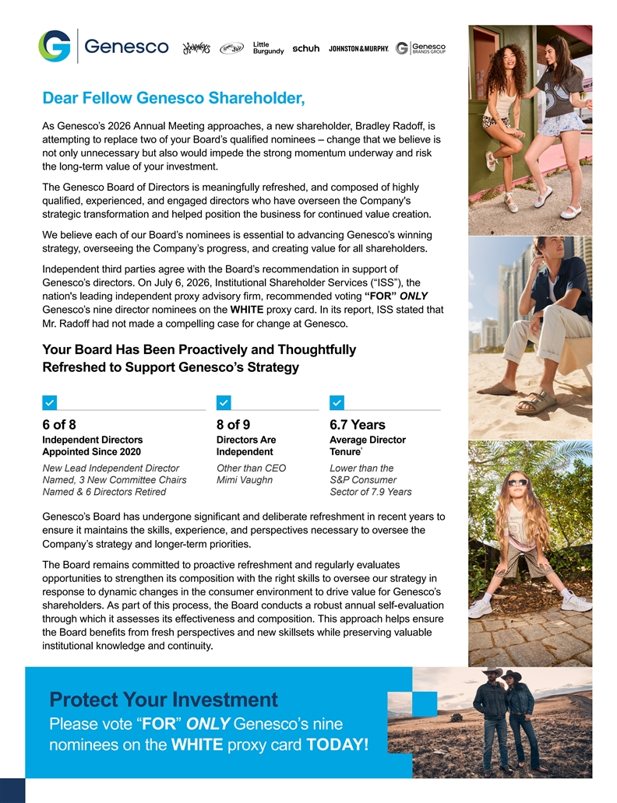
Dear Fellow Genesco Shareholder, As Genesco’s 2026 Annual Meeting approaches, a new shareholder, Bradley Rado, i ff s attempting to replace two of your Board’s qualified nominees – change that we believe is not only unnecessary but also would impede the strong momentum underway and risk the long-term value of your investment. The Genesco Board of Directors is meaningfully refreshed, and composed of highly qualified, experienced, and engaged directors who have overseen the Company's strategic transformation and helped position the business for continued value creation. We believe each of our Board’s nominees is essential to advancing Genesco’s winning strategy, overseeing the Company’s progress, and creating value for all shareholders. Independent third parties agree with the Board’s recommendation in support of Genesco’s directors. On July 6, 2026, Institutional Shareholder Services (“ISS”), the nation's leading independent proxy advisory firm, recommended voting “FOR” ONLY Genesco’s nine director nominees on the WHITE proxy card. In its report, ISS stated that Mr. Radoff had not made a compelling case for change at Genesco. Your Board Has Been Proactively and Thoughtfully Refreshed to Support Genesco’s Strategy 6 of 8 8 of 9 6.7 Years Independent Directors Directors Are Average Director 1 Appointed Since 2020 Independent Tenure New Lead Independent Director Other than CEO Lower than the Named, 3 New Committee Chairs Mimi Vaughn S&P Consumer Named & 6 Directors Retired Sector of 7.9 Years Genesco’s Board has undergone signic fi ant and deliberate refreshment in recent years to ensure it maintains the skills, experience, and perspectives necessary to oversee the Company’s strategy and longer-term priorities. The Board remains committed to proactive refreshment and regularly evaluates opportunities to strengthen its composition with the right skills to oversee our strategy in response to dynamic changes in the consumer environment to drive value for Genesco’s shareholders. As part of this process, the Board conducts a robust annual self-evaluation through which it assesses its ee ff ctiveness and composition. This approach helps ensure the Board benetfi s from fresh perspectives and new skillsets while preserving valuable institutional knowledge and continuity. Protect Your Investment Please vote “FOR” ONLY Genesco’s nine nominees on the WHITE proxy card TODAY!

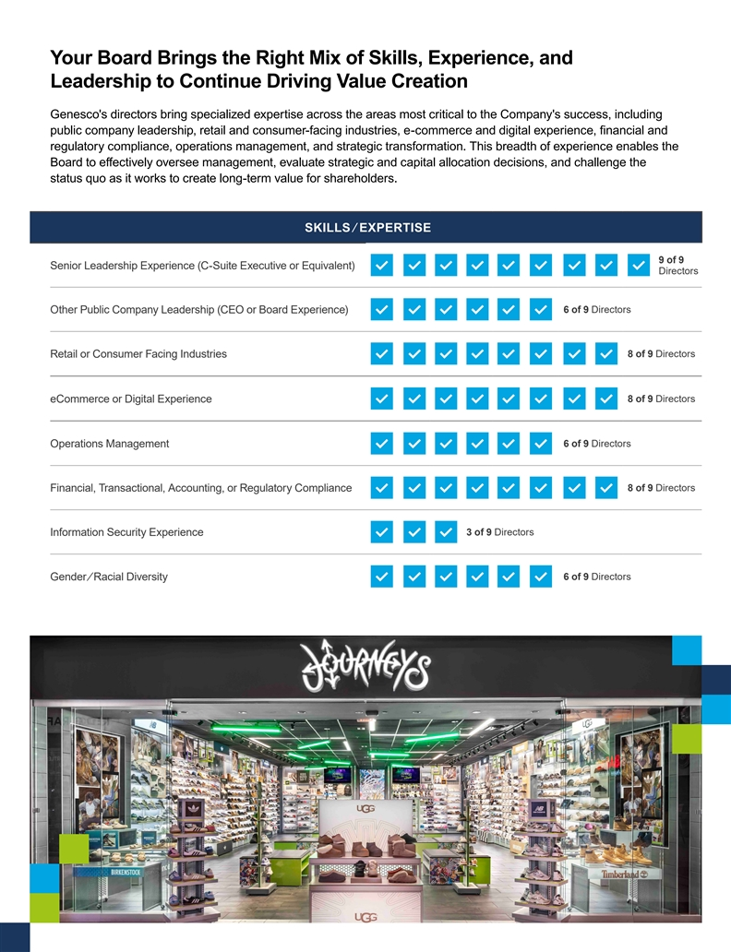
Your Board Brings the Right Mix of Skills, Experience, and Leadership to Continue Driving Value Creation Genesco's directors bring specialized expertise across the areas most critical to the Company's success, including public company leadership, retail and consumer-facing industries, e-commerce and digital experience, financial and regulatory compliance, operations management, and strategic transformation. This breadth of experience enables the Board to ee ff ctively oversee management, evaluate strategic and capital allocation decisions, and challenge the status quo as it works to create long-term value for shareholders. SKILLS / EXPERTISE 9 of 9 Senior Leadership Experience (C-Suite Executive or Equivalent) Directors O ther Public Company Leadership (CEO or Board Experience) 6 of 9 Directors R etail or Consumer Facing Industries 8 of 9 Directors e Commerce or Digital Experience 8 of 9 Directors O perations Management 6 of 9 Directors F inancial, Transactional, Accounting, or Regulatory Compliance 8 of 9 Directors Information Security Experience 3 of 9 Directors Gender / Racial Diversity 6 of 9 Directors

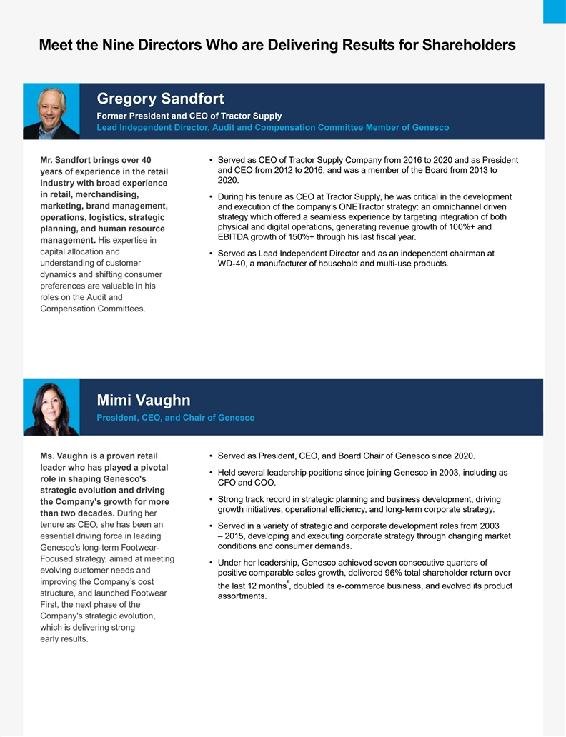
Meet the Nine Directors Who are Delivering Results for Shareholders Gregory Sandfort Former President and CEO of Tractor Supply Lead Independent Director, Audit and Compensation Committee Member of Genesco Mr. Sandfort brings over 40 • Served as CEO of Tractor Supply Company from 2016 to 2020 and as President and CEO from 2012 to 2016, and was a member of the Board from 2013 to years of experience in the retail 2020. industry with broad experience in retail, merchandising, • During his tenure as CEO at Tractor Supply, he was critical in the development marketing, brand management, and execution of the company’s ONETractor strategy: an omnichannel driven operations, logistics, strategic strategy which oe ff red a seamless experience by targeting integration of both physical and digital operations, generating revenue growth of 100%+ and planning, and human resource EBITDA growth of 150%+ through his last fiscal year. management. His expertise in capital allocation and • Served as Lead Independent Director and as an independent chairman at understanding of customer WD-40, a manufacturer of household and multi-use products. dynamics and shifting consumer preferences are valuable in his roles on the Audit and Compensation Committees. Mimi Vaughn President, CEO, and Chair of Genesco Ms. Vaughn is a proven retail • Served as President, CEO, and Board Chair of Genesco since 2020. leader who has played a pivotal • Held several leadership positions since joining Genesco in 2003, including as role in shaping Genesco's CFO and COO. strategic evolution and driving • Strong track record in strategic planning and business development, driving the Company's growth for more growth initiatives, operational efficiency, and long-term corporate strategy. than two decades. During her tenure as CEO, she has been an • Served in a variety of strategic and corporate development roles from 2003 essential driving force in leading – 2015, developing and executing corporate strategy through changing market conditions and consumer demands. Genesco’s long-term Footwear- Focused strategy, aimed at meeting • Under her leadership, Genesco achieved seven consecutive quarters of evolving customer needs and positive comparable sales growth, delivered 96% total shareholder return over improving the Company’s cost 2 the last 12 months , doubled its e-commerce business, and evolved its product structure, and launched Footwear assortments. First, the next phase of the Company's strategic evolution, which is delivering strong early results.

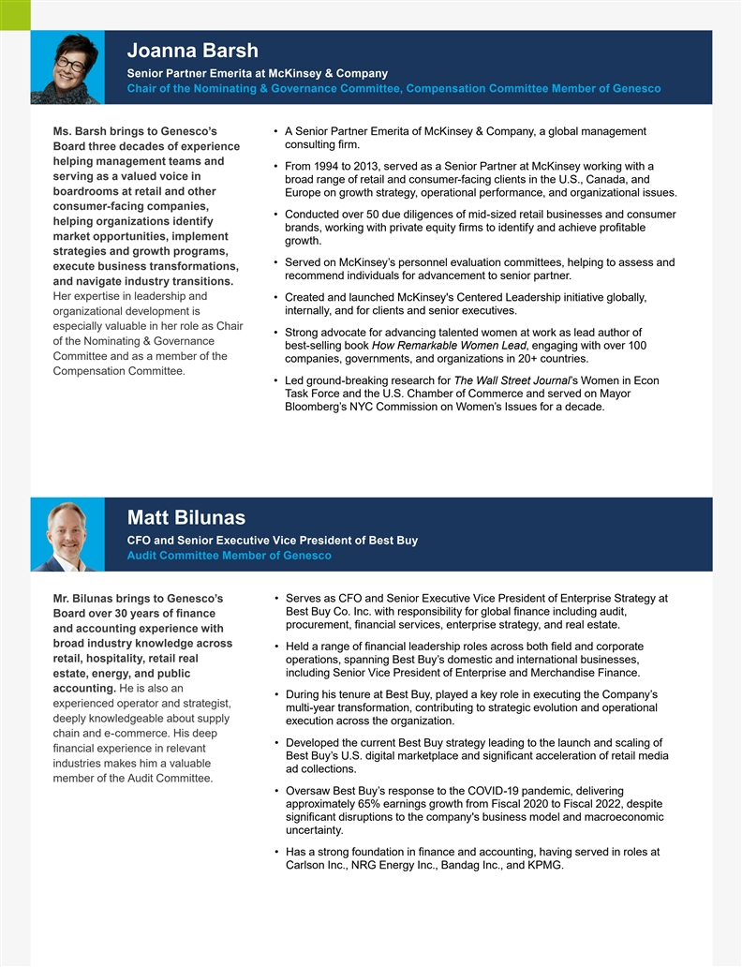
Joanna Barsh Senior Partner Emerita at McKinsey & Company Chair of the Nominating & Governance Committee, Compensation Committee Member of Genesco Ms. Barsh brings to Genesco’s • A Senior Partner Emerita of McKinsey & Company, a global management consulting firm. Board three decades of experience helping management teams and • From 1994 to 2013, served as a Senior Partner at McKinsey working with a serving as a valued voice in broad range of retail and consumer-facing clients in the U.S., Canada, and boardrooms at retail and other Europe on growth strategy, operational performance, and organizational issues. consumer-facing companies, • Conducted over 50 due diligences of mid-sized retail businesses and consumer helping organizations identify brands, working with private equity firms to identify and achieve profitable market opportunities, implement growth. strategies and growth programs, • Served on McKinsey’s personnel evaluation committees, helping to assess and execute business transformations, recommend individuals for advancement to senior partner. and navigate industry transitions. Her expertise in leadership and • Created and launched McKinsey's Centered Leadership initiative globally, organizational development is internally, and for clients and senior executives. especially valuable in her role as Chair • Strong advocate for advancing talented women at work as lead author of of the Nominating & Governance best-selling book How Remarkable Women Lead, engaging with over 100 Committee and as a member of the companies, governments, and organizations in 20+ countries. Compensation Committee. • Led ground-breaking research for The Wall Street Journal’s Women in Econ Task Force and the U.S. Chamber of Commerce and served on Mayor Bloomberg’s NYC Commission on Women’s Issues for a decade. Matt Bilunas CFO and Senior Executive Vice President of Best Buy Audit Committee Member of Genesco Mr. Bilunas brings to Genesco’s • Serves as CFO and Senior Executive Vice President of Enterprise Strategy at Best Buy Co. Inc. with responsibility for global finance including audit, Board over 30 years of finance procurement, financial services, enterprise strategy, and real estate. and accounting experience with broad industry knowledge across • Held a range of financial leadership roles across both field and corporate retail, hospitality, retail real operations, spanning Best Buy’s domestic and international businesses, estate, energy, and public including Senior Vice President of Enterprise and Merchandise Finance. accounting. He is also an • During his tenure at Best Buy, played a key role in executing the Company’s experienced operator and strategist, multi-year transformation, contributing to strategic evolution and operational deeply knowledgeable about supply execution across the organization. chain and e-commerce. His deep • Developed the current Best Buy strategy leading to the launch and scaling of financial experience in relevant Best Buy’s U.S. digital marketplace and significant acceleration of retail media industries makes him a valuable ad collections. member of the Audit Committee. • Oversaw Best Buy’s response to the COVID-19 pandemic, delivering approximately 65% earnings growth from Fiscal 2020 to Fiscal 2022, despite significant disruptions to the company's business model and macroeconomic uncertainty. • Has a strong foundation in finance and accounting, having served in roles at Carlson Inc., NRG Energy Inc., Bandag Inc., and KPMG.

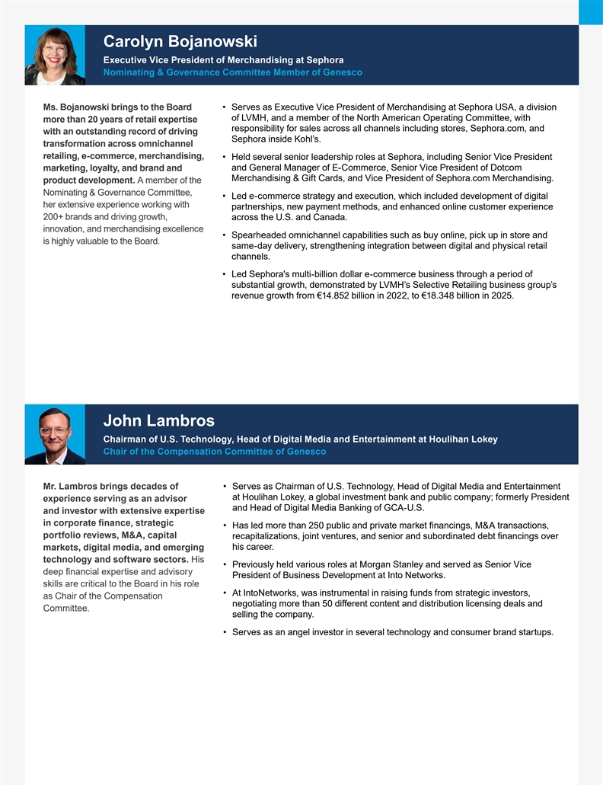
Carolyn Bojanowski Executive Vice President of Merchandising at Sephora Nominating & Governance Committee Member of Genesco Ms. Bojanowski brings to the Board • Serves as Executive Vice President of Merchandising at Sephora USA, a division of LVMH, and a member of the North American Operating Committee, with more than 20 years of retail expertise responsibility for sales across all channels including stores, Sephora.com, and with an outstanding record of driving Sephora inside Kohl’s. transformation across omnichannel retailing, e-commerce, merchandising, • Held several senior leadership roles at Sephora, including Senior Vice President and General Manager of E-Commerce, Senior Vice President of Dotcom marketing, loyalty, and brand and Merchandising & Gift Cards, and Vice President of Sephora.com Merchandising. product development. A member of the Nominating & Governance Committee, • Led e-commerce strategy and execution, which included development of digital her extensive experience working with partnerships, new payment methods, and enhanced online customer experience 200+ brands and driving growth, across the U.S. and Canada. innovation, and merchandising excellence • Spearheaded omnichannel capabilities such as buy online, pick up in store and is highly valuable to the Board. same-day delivery, strengthening integration between digital and physical retail channels. • Led Sephora's multi-billion dollar e-commerce business through a period of substantial growth, demonstrated by LVMH’s Selective Retailing business group’s revenue growth from €14.852 billion in 2022, to €18.348 billion in 2025. John Lambros Chairman of U.S. Technology, Head of Digital Media and Entertainment at Houlihan Lokey Chair of the Compensation Committee of Genesco Mr. Lambros brings decades of • Serves as Chairman of U.S. Technology, Head of Digital Media and Entertainment at Houlihan Lokey, a global investment bank and public company; formerly President experience serving as an advisor and Head of Digital Media Banking of GCA-U.S. and investor with extensive expertise in corporate finance, strategic • Has led more than 250 public and private market financings, M&A transactions, portfolio reviews, M&A, capital recapitalizations, joint ventures, and senior and subordinated debt financings over markets, digital media, and emerging his career. technology and software sectors. His • Previously held various roles at Morgan Stanley and served as Senior Vice deep financial expertise and advisory President of Business Development at Into Networks. skills are critical to the Board in his role • At IntoNetworks, was instrumental in raising funds from strategic investors, as Chair of the Compensation negotiating more than 50 die ff rent content and distribution licensing deals and Committee. selling the company. • Serves as an angel investor in several technology and consumer brand startups.

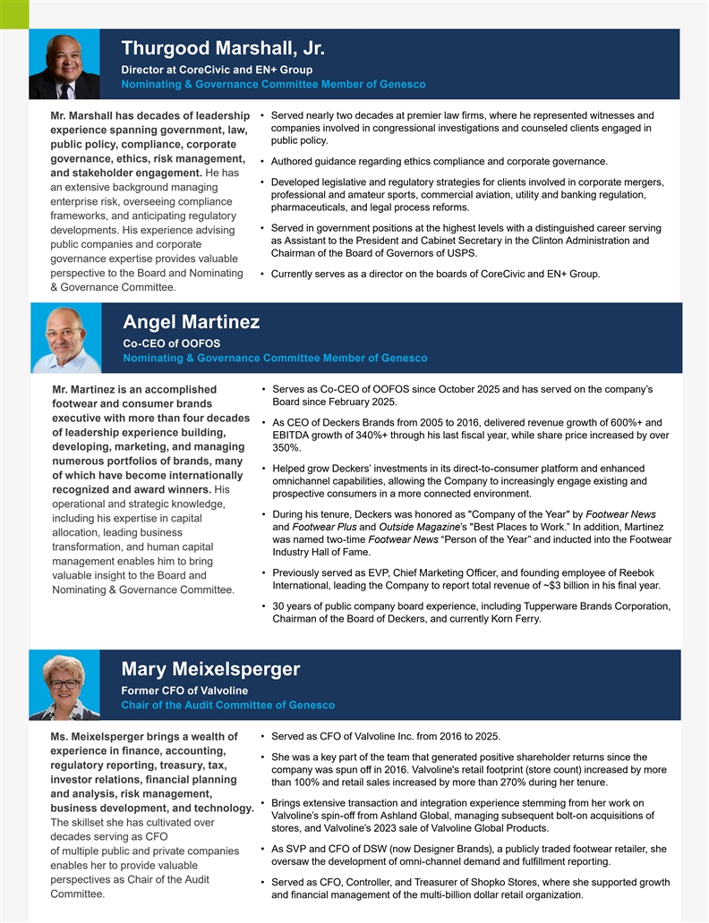
Thurgood Marshall, Jr. Director at CoreCivic and EN+ Group Nominating & Governance Committee Member of Genesco Mr. Marshall has decades of leadership • Served nearly two decades at premier law firms, where he represented witnesses and companies involved in congressional investigations and counseled clients engaged in experience spanning government, law, public policy. public policy, compliance, corporate governance, ethics, risk management, • Authored guidance regarding ethics compliance and corporate governance. and stakeholder engagement. He has • Developed legislative and regulatory strategies for clients involved in corporate mergers, an extensive background managing professional and amateur sports, commercial aviation, utility and banking regulation, enterprise risk, overseeing compliance pharmaceuticals, and legal process reforms. frameworks, and anticipating regulatory • Served in government positions at the highest levels with a distinguished career serving developments. His experience advising as Assistant to the President and Cabinet Secretary in the Clinton Administration and public companies and corporate Chairman of the Board of Governors of USPS. governance expertise provides valuable perspective to the Board and Nominating • Currently serves as a director on the boards of CoreCivic and EN+ Group. & Governance Committee. Angel Martinez Co-CEO of OOFOS Nominating & Governance Committee Member of Genesco • Serves as Co-CEO of OOFOS since October 2025 and has served on the company’s Mr. Martinez is an accomplished Board since February 2025. footwear and consumer brands executive with more than four decades • As CEO of Deckers Brands from 2005 to 2016, delivered revenue growth of 600%+ and of leadership experience building, EBITDA growth of 340%+ through his last fiscal year, while share price increased by over developing, marketing, and managing 350%. numerous portfolios of brands, many • Helped grow Deckers’ investments in its direct-to-consumer platform and enhanced of which have become internationally omnichannel capabilities, allowing the Company to increasingly engage existing and recognized and award winners. His prospective consumers in a more connected environment. operational and strategic knowledge, • During his tenure, Deckers was honored as Company of the Year by Footwear News including his expertise in capital and Footwear Plus and Outside Magazine’s Best Places to Work.” In addition, Martinez allocation, leading business was named two-time Footwear News “Person of the Year” and inducted into the Footwear transformation, and human capital Industry Hall of Fame. management enables him to bring • Previously served as EVP, Chief Marketing Officer, and founding employee of Reebok valuable insight to the Board and International, leading the Company to report total revenue of ~$3 billion in his final year. Nominating & Governance Committee. • 30 years of public company board experience, including Tupperware Brands Corporation, Chairman of the Board of Deckers, and currently Korn Ferry. Mary Meixelsperger Former CFO of Valvoline Chair of the Audit Committee of Genesco • Served as CFO of Valvoline Inc. from 2016 to 2025. Ms. Meixelsperger brings a wealth of experience in finance, accounting, • She was a key part of the team that generated positive shareholder returns since the regulatory reporting, treasury, tax, company was spun off in 2016. Valvoline's retail footprint (store count) increased by more investor relations, n fi ancial planning than 100% and retail sales increased by more than 270% during her tenure. and analysis, risk management, • Brings extensive transaction and integration experience stemming from her work on business development, and technology. Valvoline’s spin-off from Ashland Global, managing subsequent bolt-on acquisitions of The skillset she has cultivated over stores, and Valvoline’s 2023 sale of Valvoline Global Products. decades serving as CFO • As SVP and CFO of DSW (now Designer Brands), a publicly traded footwear retailer, she of multiple public and private companies oversaw the development of omni-channel demand and fulfillment reporting. enables her to provide valuable perspectives as Chair of the Audit • Served as CFO, Controller, and Treasurer of Shopko Stores, where she supported growth Committee. and financial management of the multi-billion dollar retail organization.

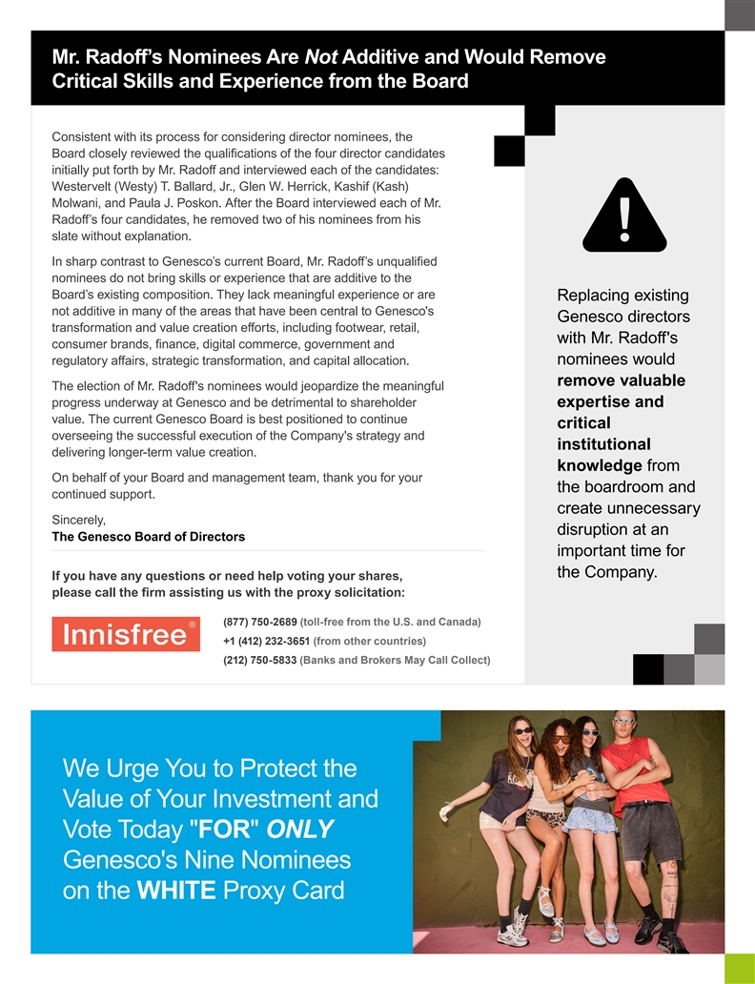
Mr. Radoff’s Nominees Are Not Additive and Would Remove Critical Skills and Experience from the Board Consistent with its process for considering director nominees, the Board closely reviewed the qualic fi ations of the four director candidates initially put forth by Mr. Radoff and interviewed each of the candidates: Westervelt (Westy) T. Ballard, Jr., Glen W. Herrick, Kashif (Kash) Molwani, and Paula J. Poskon. After the Board interviewed each of Mr. Radoff’s four candidates, he removed two of his nominees from his slate without explanation. In sharp contrast to Genesco’s current Board, Mr. Radoff’s unqualified nominees do not bring skills or experience that are additive to the Board’s existing composition. They lack meaningful experience or are Replacing existing not additive in many of the areas that have been central to Genesco's Genesco directors transformation and value creation eo ff rts, including footwear, retail, with Mr. Radoff's consumer brands, finance, digital commerce, government and regulatory aai ff rs, strategic transformation, and capital allocation. nominees would remove valuable The election of Mr. Radoff's nominees would jeopardize the meaningful progress underway at Genesco and be detrimental to shareholder expertise and value. The current Genesco Board is best positioned to continue critical overseeing the successful execution of the Company's strategy and institutional delivering longer-term value creation. knowledge from On behalf of your Board and management team, thank you for your the boardroom and continued support. create unnecessary Sincerely, disruption at an The Genesco Board of Directors important time for the Company. If you have any questions or need help voting your shares, please call the firm assisting us with the proxy solicitation: (877) 750-2689 (toll-free from the U.S. and Canada) +1 (412) 232-3651 (from other countries) (212) 750-5833 (Banks and Brokers May Call Collect) We Urge You to Protect the Value of Your Investment and Vote Today FOR ONLY Genesco's Nine Nominees on the WHITE Proxy Card

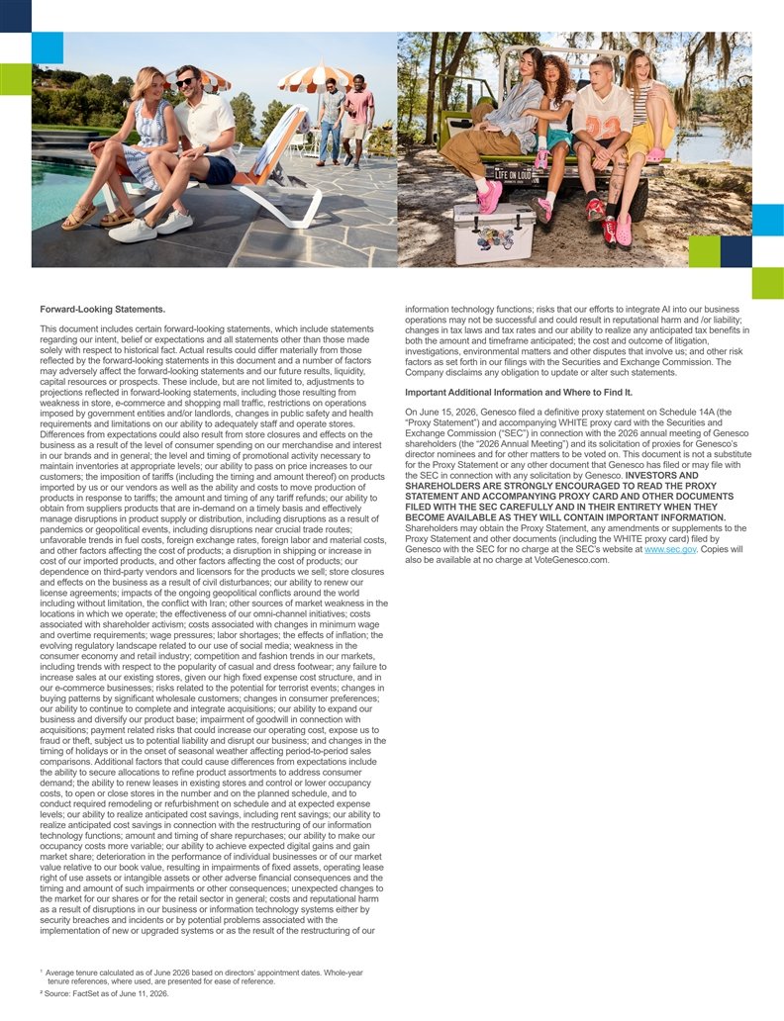
Forward-Looking Statements. information technology functions; risks that our efforts to integrate AI into our business operations may not be successful and could result in reputational harm and /or liability; This document includes certain forward-looking statements, which include statements changes in tax laws and tax rates and our ability to realize any anticipated tax benefits in regarding our intent, belief or expectations and all statements other than those made both the amount and timeframe anticipated; the cost and outcome of litigation, solely with respect to historical fact. Actual results could differ materially from those investigations, environmental matters and other disputes that involve us; and other risk reflected by the forward-looking statements in this document and a number of factors factors as set forth in our filings with the Securities and Exchange Commission. The may adversely affect the forward-looking statements and our future results, liquidity, Company disclaims any obligation to update or alter such statements. capital resources or prospects. These include, but are not limited to, adjustments to projections reflected in forward-looking statements, including those resulting from Important Additional Information and Where to Find It. weakness in store, e-commerce and shopping mall traffic, restrictions on operations On June 15, 2026, Genesco filed a definitive proxy statement on Schedule 14A (the imposed by government entities and/or landlords, changes in public safety and health “Proxy Statement”) and accompanying WHITE proxy card with the Securities and requirements and limitations on our ability to adequately staff and operate stores. Exchange Commission (“SEC”) in connection with the 2026 annual meeting of Genesco Differences from expectations could also result from store closures and effects on the shareholders (the “2026 Annual Meeting”) and its solicitation of proxies for Genesco’s business as a result of the level of consumer spending on our merchandise and interest director nominees and for other matters to be voted on. This document is not a substitute in our brands and in general; the level and timing of promotional activity necessary to for the Proxy Statement or any other document that Genesco has filed or may file with maintain inventories at appropriate levels; our ability to pass on price increases to our the SEC in connection with any solicitation by Genesco. INVESTORS AND customers; the imposition of tariffs (including the timing and amount thereof) on products SHAREHOLDERS ARE STRONGLY ENCOURAGED TO READ THE PROXY imported by us or our vendors as well as the ability and costs to move production of STATEMENT AND ACCOMPANYING PROXY CARD AND OTHER DOCUMENTS products in response to tariffs; the amount and timing of any tariff refunds; our ability to FILED WITH THE SEC CAREFULLY AND IN THEIR ENTIRETY WHEN THEY obtain from suppliers products that are in-demand on a timely basis and effectively BECOME AVAILABLE AS THEY WILL CONTAIN IMPORTANT INFORMATION. manage disruptions in product supply or distribution, including disruptions as a result of Shareholders may obtain the Proxy Statement, any amendments or supplements to the pandemics or geopolitical events, including disruptions near crucial trade routes; Proxy Statement and other documents (including the WHITE proxy card) filed by unfavorable trends in fuel costs, foreign exchange rates, foreign labor and material costs, Genesco with the SEC for no charge at the SEC’s website at www.sec.gov . Copies will and other factors affecting the cost of products; a disruption in shipping or increase in also be available at no charge at VoteGenesco.com. cost of our imported products, and other factors affecting the cost of products; our dependence on third-party vendors and licensors for the products we sell; store closures and effects on the business as a result of civil disturbances; our ability to renew our license agreements; impacts of the ongoing geopolitical conflicts around the world including without limitation, the conflict with Iran; other sources of market weakness in the locations in which we operate; the effectiveness of our omni-channel initiatives; costs associated with shareholder activism; costs associated with changes in minimum wage and overtime requirements; wage pressures; labor shortages; the effects of inflation; the evolving regulatory landscape related to our use of social media; weakness in the consumer economy and retail industry; competition and fashion trends in our markets, including trends with respect to the popularity of casual and dress footwear; any failure to increase sales at our existing stores, given our high fixed expense cost structure, and in our e-commerce businesses; risks related to the potential for terrorist events; changes in buying patterns by significant wholesale customers; changes in consumer preferences; our ability to continue to complete and integrate acquisitions; our ability to expand our business and diversify our product base; impairment of goodwill in connection with acquisitions; payment related risks that could increase our operating cost, expose us to fraud or theft, subject us to potential liability and disrupt our business; and changes in the timing of holidays or in the onset of seasonal weather affecting period-to-period sales comparisons. Additional factors that could cause differences from expectations include the ability to secure allocations to refine product assortments to address consumer demand; the ability to renew leases in existing stores and control or lower occupancy costs, to open or close stores in the number and on the planned schedule, and to conduct required remodeling or refurbishment on schedule and at expected expense levels; our ability to realize anticipated cost savings, including rent savings; our ability to realize anticipated cost savings in connection with the restructuring of our information technology functions; amount and timing of share repurchases; our ability to make our occupancy costs more variable; our ability to achieve expected digital gains and gain market share; deterioration in the performance of individual businesses or of our market value relative to our book value, resulting in impairments of fixed assets, operating lease right of use assets or intangible assets or other adverse financial consequences and the timing and amount of such impairments or other consequences; unexpected changes to the market for our shares or for the retail sector in general; costs and reputational harm as a result of disruptions in our business or information technology systems either by security breaches and incidents or by potential problems associated with the implementation of new or upgraded systems or as the result of the restructuring of our 1 Average tenure calculated as of June 2026 based on directors’ appointment dates. Whole-year tenure references, where used, are presented for ease of reference. 2 Source: FactSet as of June 11, 2026.

