UNITED STATES
SECURITIES AND EXCHANGE COMMISSION
Washington, D.C. 20549

SCHEDULE 14A
(Rule 14a-101)

INFORMATION REQUIRED IN PROXY STATEMENT

SCHEDULE 14A INFORMATION

Proxy Statement Pursuant to Section 14(a) of the Securities Exchange Act of 1934

(Amendment No. )

Filed by the Registrant ☐

Filed by a Party other than the Registrant ☒

Check the appropriate box:

 | ☐ | Preliminary Proxy Statement

 | ☐ | Confidential, for Use of the Commission Only (as permitted by Rule 14a-6(e)(2))

 | ☐ | Definitive Proxy Statement

 | ☒ | Definitive Additional Materials

 | ☐ | Soliciting Material Under § 240.14a-12

GENESCO INC.
(Name of Registrant as Specified In Its Charter)
Bradley l. radoff
Jumana Capital Investments LLC
Christopher R. MartiN
Westervelt T. Ballard, Jr.
Paula J. Poskon
(Name of Persons(s) Filing Proxy Statement, if other than the Registrant)

Payment of Filing Fee (Check all boxes that apply):

 | ☒ | No fee required

 | ☐ | Fee paid previously with preliminary materials

 | ☐ | Fee computed on table in exhibit required by Item 25(b) per Exchange Act Rules 14a-6(i)(1) and 0-11

Bradley L. Radoff, Jumana Capital Investments LLC, Christopher R. Martin and the other participants named herein (collectively, the “Radoff-Jumana Group”) have filed a definitive proxy statement and accompanying GOLD universal proxy card with the Securities and Exchange Commission to be used to solicit votes for the election of its slate of highly qualified director nominees at the 2026 annual meeting of shareholders of Genesco Inc., a Tennessee corporation (the “Company”).

Item 1: On July 6, 2026, the Radoff-Jumana Group issued the following press release:

The Radoff-Jumana Group Highlights Genesco Inc.’s Value Destruction and Calls for CEO Mimi Vaughn to Step Down as Chair of the Board of Directors

Issues Rebuttal Presentation Highlighting How Genesco’s July 1 Presentation Uses ‘Mimi Math’ to Cherry-Pick a Depressed Starting Share Price and Artificially High Ending Share Price in Order to Make the Company’s Performance Appear Better Than It Actually Is – Stock Is Down More Than 22% Since Cherry-Picked Date

Believes This Is the Latest Example of the Board Manipulating the Facts and Calls for Ms. Vaughn to Be Stripped of Her Board Chair Role

Calls on Genesco to Return Excess Cash to Shareholders via a Dutch Tender Offer for 1 Million Shares at the Earliest Possible Opportunity

HOUSTON--(BUSINESS WIRE)--Bradley L. Radoff, Jumana Capital Investments LLC and Christopher R. Martin (collectively, the “Radoff-Jumana Group” or “we”), who collectively own approximately 9.1% of the outstanding shares of Genesco Inc. (NYSE: GCO) (“Genesco” or the “Company”), today released a rebuttal presentation spotlighting several false and misleading claims made in the Company’s July 1, 2026 presentation.

The Radoff-Jumana Group also issued the following statement:

“Given the Board’s latest manipulation of the facts, we once again call for Ms. Vaughn to be stripped of the Chair role. It is clear to us that there is zero accountability in the boardroom so long as Ms. Vaughn is calling the shots. In fact, the Board should promote Andrew Gray to CEO if Ms. Vaughn continues to waste shareholder resources in an attempt to mislead investors and maintain her grip on the Company – he is effectively already running the business as CEO of the profitable Journeys segment.

We also urge the Company to conduct a Dutch tender offer for 1 million shares. The Company has excess cash, in our view, following its receipt of a $58.7 million tax refund and anticipated $23-$25 million tariff refund.1 With excess real estate, inventory and overhead costs, we demand all excess cash be returned to shareholders at the soonest possible opportunity.”

***

Vote FOR the Radoff-Jumana Group’s Nominees – Westervelt T. Ballard, Jr. and Paula J. Poskon – Today to Hold the Legacy Board Accountable for Years of Value Destruction and Send a Clear Signal for Change

1 Company Q1 2027 earnings press release dated May 29, 2026. Company Form 10-K for the fiscal year ended January 31, 2026 filed on March 25, 2026.

Do NOT Vote for Joanna Barsh or Thurgood Marshall, Jr.

Questions about how to vote? Contact (888) 368-0379 or info@saratogaproxy.com

Visit www.saratogaproxy.com/Genesco to learn more

Contacts
Greg Lempel
greg@fondrenlp.com

or

Saratoga Proxy Consulting LLC
John Ferguson / Joseph Mills, 212-257-1311
info@saratogaproxy.com

Item 2: Also on July 6, 2026, the Radoff-Jumana Group issued the following Investor Presentation titled “Exposing Genesco’s Most Recent Attempts to Mislead Shareholders,” a copy of which is attached hereto as Exhibit 1.

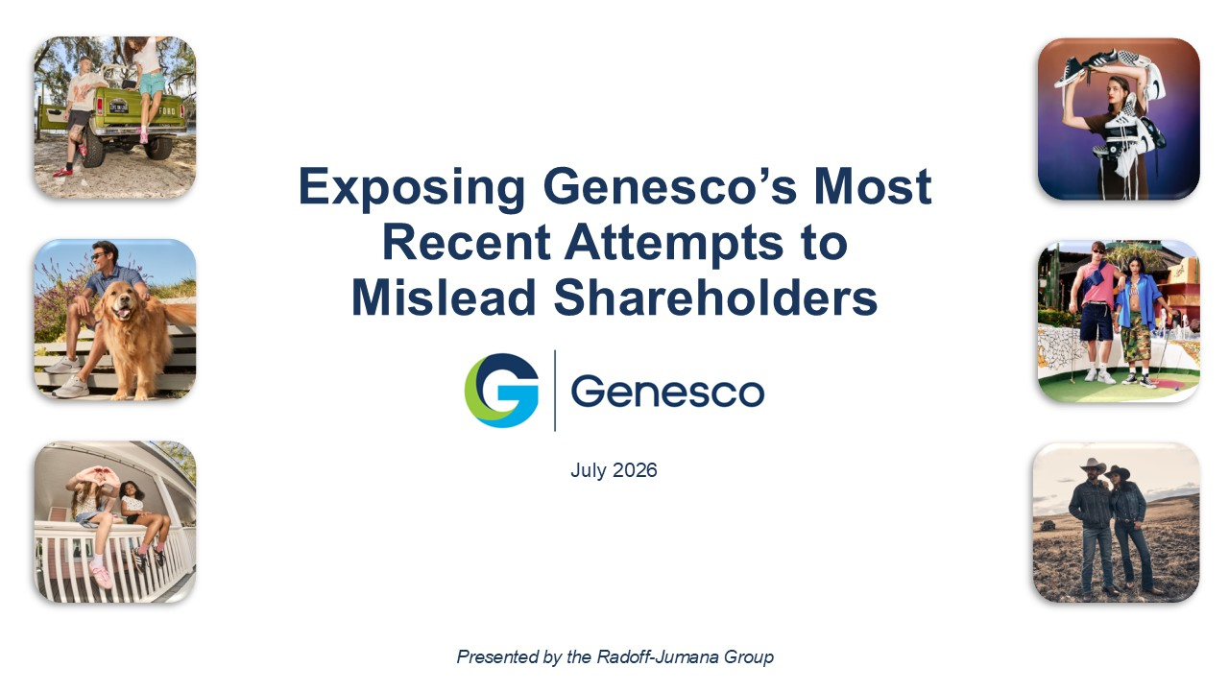
July 2026 Exposing Genesco’s Most Recent Attempts to Mislead Shareholders Presented by the Radoff - Jumana Group
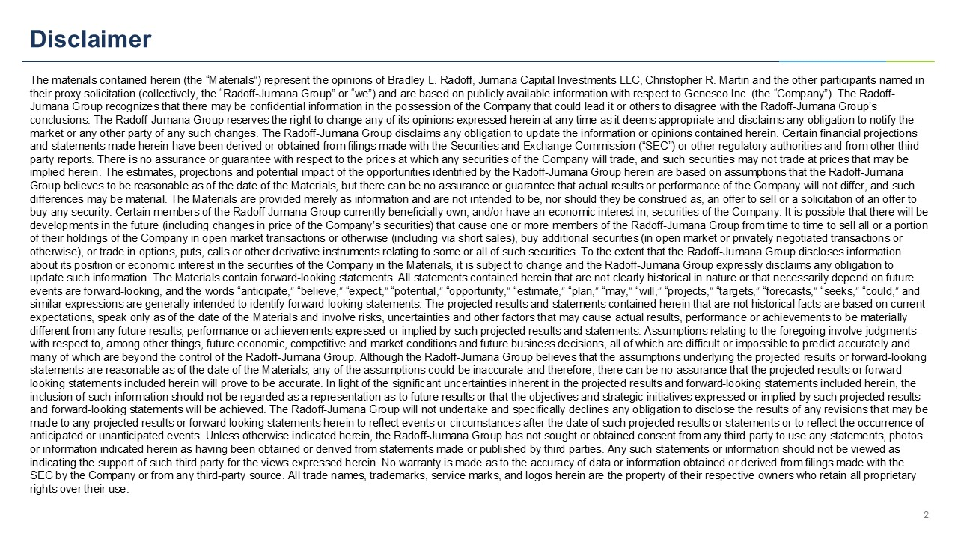
Disclaimer The materials contained herein (the “Materials”) represent the opinions of Bradley L. Radoff, Jumana Capital Investments LLC, Ch ristopher R. Martin and the other participants named in their proxy solicitation (collectively, the “Radoff - Jumana Group” or “we”) and are based on publicly available information with respect to Genesco Inc. (the “Company”). The Radoff - Jumana Group recognizes that there may be confidential information in the possession of the Company that could lead it or oth ers to disagree with the Radoff - Jumana Group’s conclusions. The Radoff - Jumana Group reserves the right to change any of its opinions expressed herein at any time as it deems a ppropriate and disclaims any obligation to notify the market or any other party of any such changes. The Radoff - Jumana Group disclaims any obligation to update the information or opi nions contained herein. Certain financial projections and statements made herein have been derived or obtained from filings made with the Securities and Exchange Commission (“SEC” ) o r other regulatory authorities and from other third party reports. There is no assurance or guarantee with respect to the prices at which any securities of the Company will trad e, and such securities may not trade at prices that may be implied herein. The estimates, projections and potential impact of the opportunities identified by the Radoff - Jumana Group herei n are based on assumptions that the Radoff - Jumana Group believes to be reasonable as of the date of the Materials, but there can be no assurance or guarantee that actual resul ts or performance of the Company will not differ, and such differences may be material. The Materials are provided merely as information and are not intended to be, nor should they be con strued as, an offer to sell or a solicitation of an offer to buy any security. Certain members of the Radoff - Jumana Group currently beneficially own, and/or have an economic interest in, se curities of the Company. It is possible that there will be developments in the future (including changes in price of the Company’s securities) that cause one or more members of the Rad off - Jumana Group from time to time to sell all or a portion of their holdings of the Company in open market transactions or otherwise (including via short sales), buy additional securit ies (in open market or privately negotiated transactions or otherwise), or trade in options, puts, calls or other derivative instruments relating to some or all of such securities. To t he extent that the Radoff - Jumana Group discloses information about its position or economic interest in the securities of the Company in the Materials, it is subject to change and the Ra dof f - Jumana Group expressly disclaims any obligation to update such information. The Materials contain forward - looking statements. All statements contained herein that are not clearly historical in nature or that necessarily depend on future events are forward - looking, and the words “anticipate,” “believe,” “expect,” “potential,” “opportunity,” “estimate,” “plan,” “ma y,” “will,” “projects,” “targets,” “forecasts,” “seeks,” “could,” and similar expressions are generally intended to identify forward - looking statements. The projected results and statements containe d herein that are not historical facts are based on current expectations, speak only as of the date of the Materials and involve risks, uncertainties and other factors that may cause ac tua l results, performance or achievements to be materially different from any future results, performance or achievements expressed or implied by such projected results and statements. As sumptions relating to the foregoing involve judgments with respect to, among other things, future economic, competitive and market conditions and future business decisions, all of wh ich are difficult or impossible to predict accurately and many of which are beyond the control of the Radoff - Jumana Group. Although the Radoff - Jumana Group believes that the assumptions underlying the projected results or forward - looking statements are reasonable as of the date of the Materials, any of the assumptions could be inaccurate and therefore, there ca n b e no assurance that the projected results or forward - looking statements included herein will prove to be accurate. In light of the significant uncertainties inherent in the proje cte d results and forward - looking statements included herein, the inclusion of such information should not be regarded as a representation as to future results or that the objectives and stra teg ic initiatives expressed or implied by such projected results and forward - looking statements will be achieved. The Radoff - Jumana Group will not undertake and specifically declines any obliga tion to disclose the results of any revisions that may be made to any projected results or forward - looking statements herein to reflect events or circumstances after the date of such pro jected results or statements or to reflect the occurrence of anticipated or unanticipated events. Unless otherwise indicated herein, the Radoff - Jumana Group has not sought or obtained conse nt from any third party to use any statements, photos or information indicated herein as having been obtained or derived from statements made or published by third parties. Any su ch statements or information should not be viewed as indicating the support of such third party for the views expressed herein. No warranty is made as to the accuracy of data or inf ormation obtained or derived from filings made with the SEC by the Company or from any third - party source. All trade names, trademarks, service marks, and logos herein are the property of their respective owners who retain all proprietary rights over their use. 2
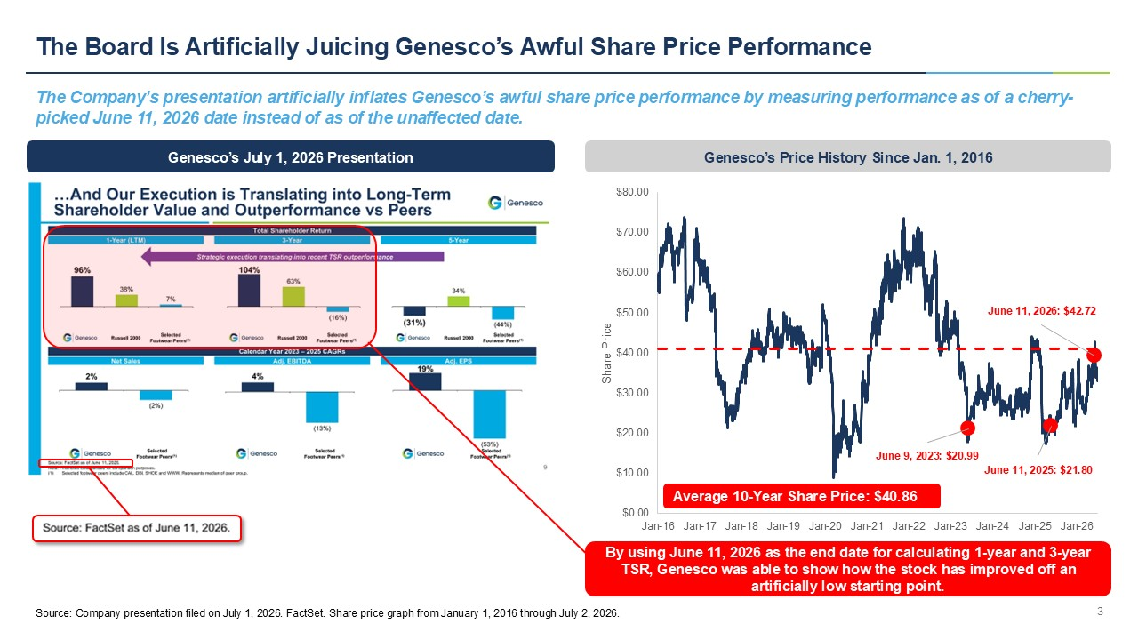
June 9, 2023: $20.99 June 11, 2025: $21.80 June 11, 2026: $42.72 $0.00 $10.00 $20.00 $30.00 $40.00 $50.00 $60.00 $70.00 $80.00 Jan-16 Jan-17 Jan-18 Jan-19 Jan-20 Jan-21 Jan-22 Jan-23 Jan-24 Jan-25 Jan-26 Share Price Average 10 - Year Share Price: $40.86 The Board Is Artificially Juicing Genesco’s Awful Share Price Performance The Company’s presentation artificially inflates Genesco’s awful share price performance by measuring performance as of a che rry - picked June 11, 2026 date instead of as of the unaffected date. 3 Genesco’s July 1, 2026 Presentation Genesco’s Price History Since Jan. 1, 2016 By using June 11, 2026 as the end date for calculating 1 - year and 3 - year TSR, Genesco was able to show how the stock has improved off an artificially low starting point. Source: Company presentation filed on July 1, 2026. FactSet. Share price graph from January 1, 2016 through July 2, 2026.
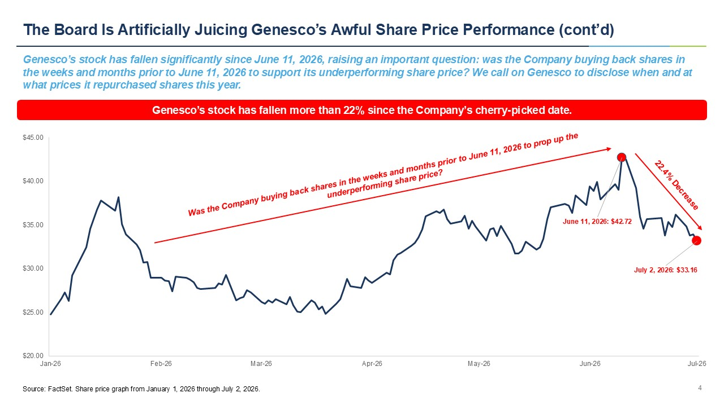
June 11, 2026: $ 42.72 July 2, 2026: $ 33.16 $20.00 $25.00 $30.00 $35.00 $40.00 $45.00 Jan-26 Feb-26 Mar-26 Apr-26 May-26 Jun-26 Jul-26 The Board Is Artificially Juicing Genesco’s Awful Share Price Performance (cont’d) Genesco’s stock has fallen significantly since June 11, 2026, raising an important question: was the Company buying back shar es in the weeks and months prior to June 11, 2026 to support its underperforming share price? We call on Genesco to disclose when a nd at what prices it repurchased shares this year. 4 Genesco’s stock has fallen more than 22% since the Company’s cherry - picked date. Source: FactSet. Share price graph from January 1, 2026 through July 2, 2026.
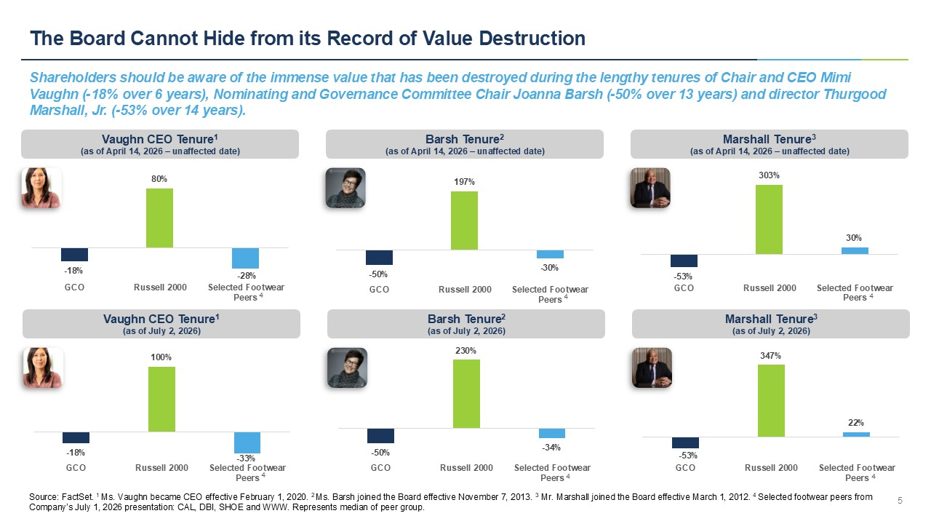
- 50% 230% - 34% GCO Russell 2000 Selected Footwear Peers - 18% 100% - 33% GCO Russell 2000 Selected Footwear Peers The Board Cannot Hide from its Record of Value Destruction Shareholders should be aware of the immense value that has been destroyed during the lengthy tenures of Chair and CEO Mimi Vaughn ( - 18% over 6 years), Nominating and Governance Committee Chair Joanna Barsh ( - 50% over 13 years) and director Thurgood Marshall, Jr. ( - 53% over 14 years). 5 - 18% 80% - 28% GCO Russell 2000 Selected Footwear Peers Vaughn CEO Tenure 1 (as of April 14, 2026 – unaffected date) - 50% 197% - 30% GCO Russell 2000 Selected Footwear Peers Barsh Tenure 2 (as of April 14, 2026 – unaffected date) - 53% 303% 30% GCO Russell 2000 Selected Footwear Peers Marshall Tenure 3 (as of April 14, 2026 – unaffected date) 4 4 4 Vaughn CEO Tenure 1 (as of July 2, 2026) Barsh Tenure 2 (as of July 2, 2026) Marshall Tenure 3 (as of July 2, 2026) 4 4 4 Source: FactSet. 1 Ms. Vaughn became CEO effective February 1, 2020. 2 Ms. Barsh joined the Board effective November 7, 2013. 3 Mr. Marshall joined the Board effective March 1, 2012. 4 Selected footwear peers from Company’s July 1, 2026 presentation: CAL, DBI, SHOE and WWW. Represents median of peer group. - 53% 347% 22% GCO Russell 2000 Selected Footwear Peers
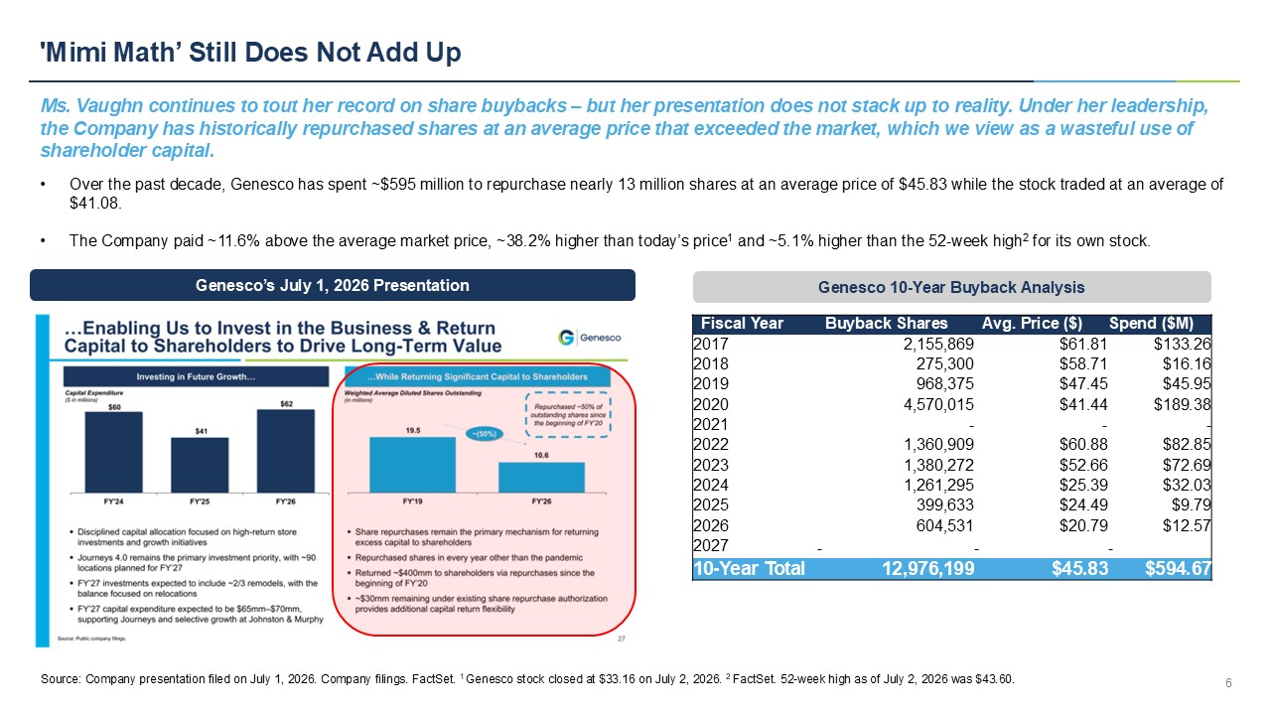
'Mimi Math’ Still Does Not Add Up Ms. Vaughn continues to tout her record on share buybacks – but her presentation does not stack up to reality. Under her leaders hip, the Company has historically repurchased shares at an average price that exceeded the market, which we view as a wasteful use of shareholder capital. 6 • Over the past decade, Genesco has spent ~$595 million to repurchase nearly 13 million shares at an average price of $45.83 wh ile the stock traded at an average of $41.08. • The Company paid ~11.6% above the average market price, ~38.2% higher than today’s price 1 and ~5.1% higher than the 52 - week high 2 for its own stock. Spend ($M) Avg. Price ($) Buyback Shares Fiscal Year $133.26 $61.81 2,155,869 2017 $16.16 $58.71 275,300 2018 $45.95 $47.45 968,375 2019 $189.38 $41.44 4,570,015 2020 - - - 2021 $82.85 $60.88 1,360,909 2022 $72.69 $52.66 1,380,272 2023 $32.03 $25.39 1,261,295 2024 $9.79 $24.49 399,633 2025 $12.57 $20.79 604,531 2026 - - - 2027 $594.67 $45.83 12,976,199 10 - Year Total Genesco 10 - Year Buyback Analysis Genesco’s July 1, 2026 Presentation Source: Company presentation filed on July 1, 2026. Company filings. FactSet. 1 Genesco stock closed at $33.16 on July 2, 2026. 2 FactSet. 52 - week high as of July 2, 2026 was $43.60.
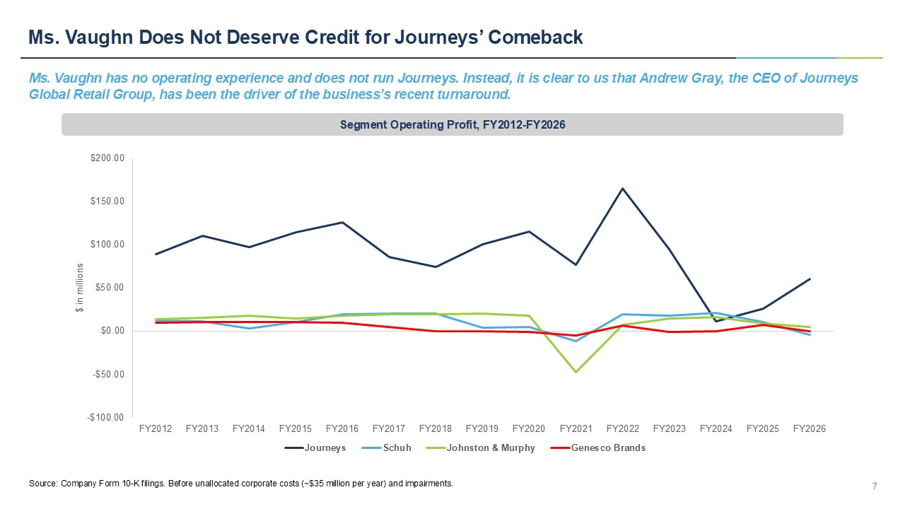
Ms. Vaughn Does Not Deserve Credit for Journeys’ Comeback Ms. Vaughn has no operating experience and does not run Journeys. Instead, it is clear to us that Andrew Gray, the CEO of Jou rne ys Global Retail Group, has been the driver of the business’s recent turnaround. 7 Segment Operating Profit, FY2012 - FY2026 Source: Company Form 10 - K filings. Before unallocated corporate costs (~$35 million per year) and impairments. -$100.00 -$50.00 $0.00 $50.00 $100.00 $150.00 $200.00 FY2012 FY2013 FY2014 FY2015 FY2016 FY2017 FY2018 FY2019 FY2020 FY2021 FY2022 FY2023 FY2024 FY2025 FY2026 $ in millions Journeys Schuh Johnston & Murphy Genesco Brands
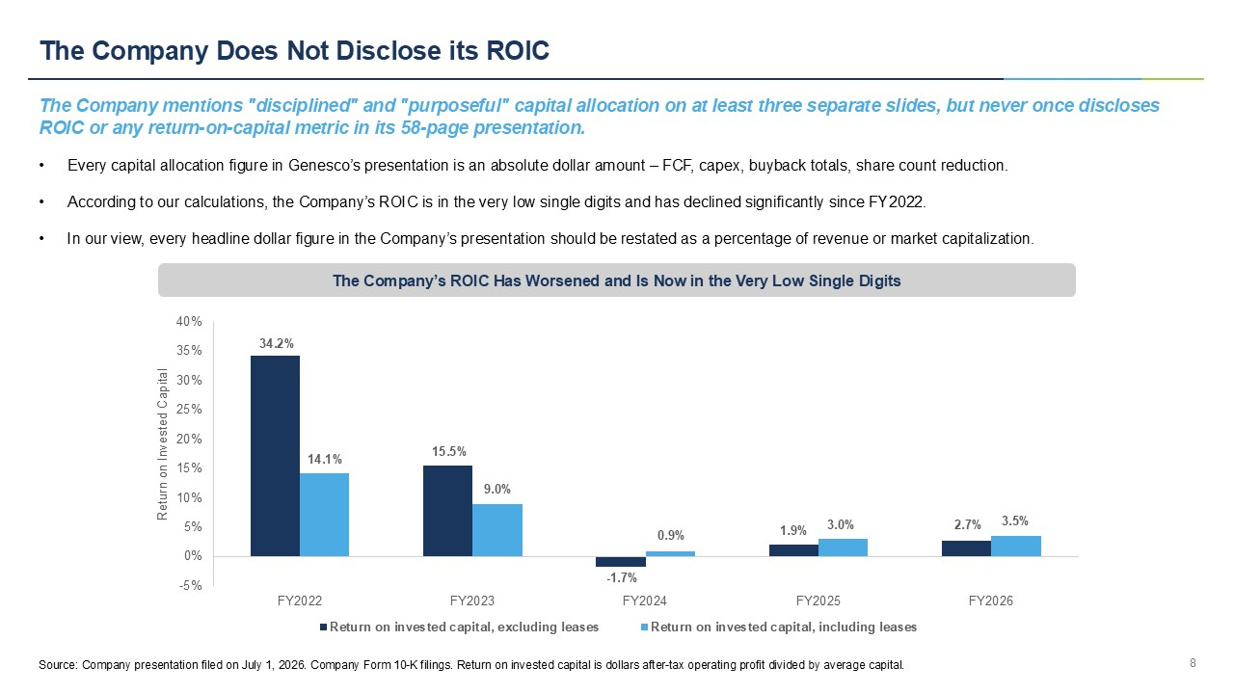
The Company Does Not Disclose its ROIC The Company mentions "disciplined" and "purposeful" capital allocation on at least three separate slides, but never once disc los es ROIC or any return - on - capital metric in its 58 - page presentation. 8 • Every capital allocation figure in Genesco’s presentation is an absolute dollar amount – FCF, capex, buyback totals, share count reduction. • According to our calculations, the Company’s ROIC is in the very low single digits and has declined significantly since FY202 2. • In our view, every headline dollar figure in the Company’s presentation should be restated as a percentage of revenue or mark et capitalization. Source: Company presentation filed on July 1, 2026. Company Form 10 - K filings. Return on invested capital is dollars after - tax o perating profit divided by average capital. -5% 0% 5% 10% 15% 20% 25% 30% 35% 40% FY2022 FY2023 FY2024 FY2025 FY2026 Return on Invested Capital Return on invested capital, excluding leases Return on invested capital, including leases 34.2% 14.1% 15.5% 9.0% - 1.7% 0.9% 1.9% 3.0% 2.7% 3.5% The Company’s ROIC Has Worsened and Is Now in the Very Low Single Digits
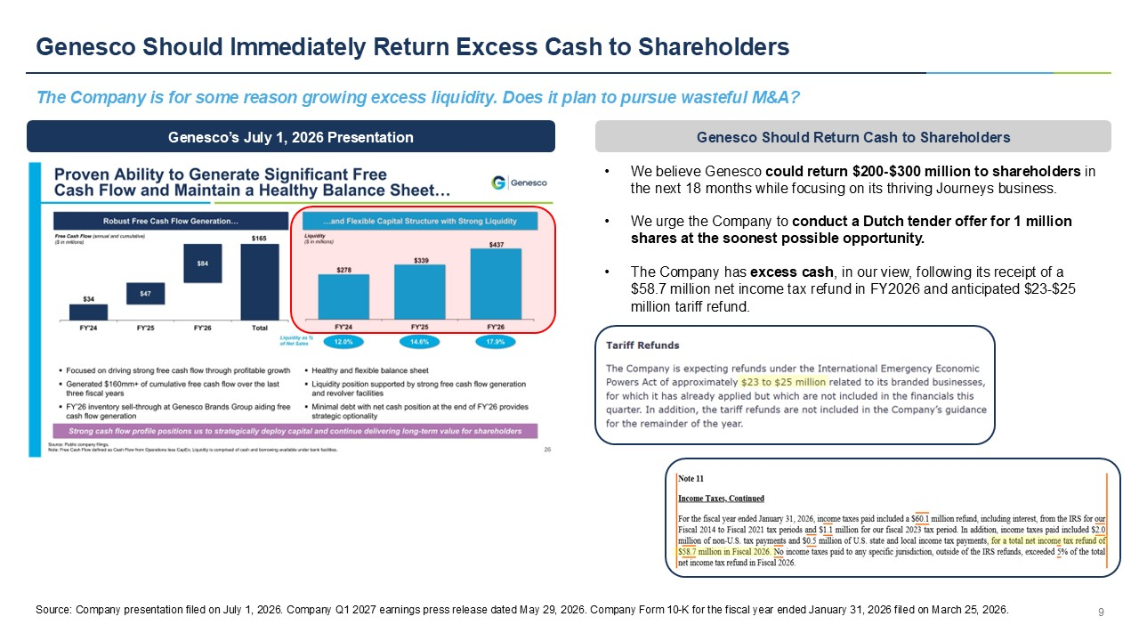
Genesco Should Immediately Return Excess Cash to Shareholders The Company is for some reason growing excess liquidity. Does it plan to pursue wasteful M&A? 9 Genesco’s July 1, 2026 Presentation • We believe Genesco could return $200 - $300 million to shareholders in the next 18 months while focusing on its thriving Journeys business. • We urge the Company to conduct a Dutch tender offer for 1 million shares at the soonest possible opportunity. • The Company has excess cash , in our view, following its receipt of a $58.7 million net income tax refund in FY2026 and anticipated $23 - $25 million tariff refund. Genesco Should Return Cash to Shareholders Source: Company presentation filed on July 1, 2026. Company Q1 2027 earnings press release dated May 29, 2026. Company Form 1 0 - K for the fiscal year ended January 31, 2026 filed on March 25, 2026.
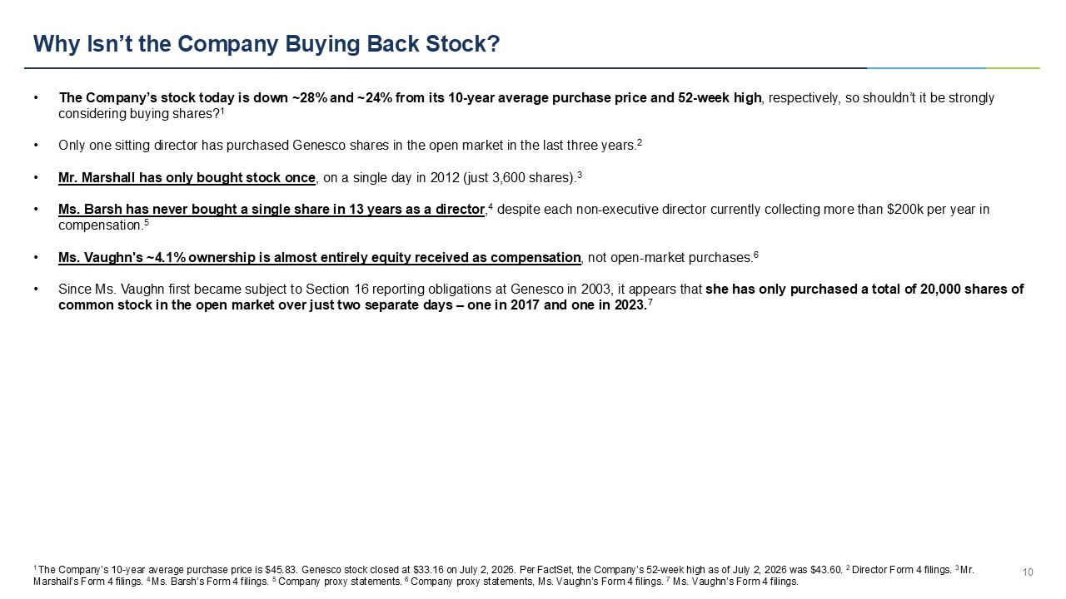
Why Isn’t the Company Buying Back Stock? 10 • The Company’s stock today is down ~28% and ~24% from its 10 - year average purchase price and 52 - week high , respectively, so shouldn’t it be strongly considering buying shares? 1 • Only one sitting director has purchased Genesco shares in the open market in the last three years. 2 • Mr. Marshall has only bought stock once , on a single day in 2012 (just 3,600 shares). 3 • Ms. Barsh has never bought a single share in 13 years as a director , 4 despite each non - executive director currently collecting more than $200k per year in compensation. 5 • Ms. Vaughn's ~4.1% ownership is almost entirely equity received as compensation , not open - market purchases. 6 • Since Ms. Vaughn first became subject to Section 16 reporting obligations at Genesco in 2003, it appears that she has only purchased a total of 20,000 shares of common stock in the open market over just two separate days – one in 2017 and one in 2023. 7 1 The Company’s 10 - year average purchase price is $45.83. Genesco stock closed at $33.16 on July 2, 2026. Per FactSet, the Company’s 52 - week high as of July 2, 2026 was $43.60. 2 Director Form 4 filings. 3 Mr. Marshall’s Form 4 filings. 4 Ms. Barsh’s Form 4 filings. 5 Company proxy statements. 6 Company proxy statements, Ms. Vaughn’s Form 4 filings. 7 Ms. Vaughn’s Form 4 filings.
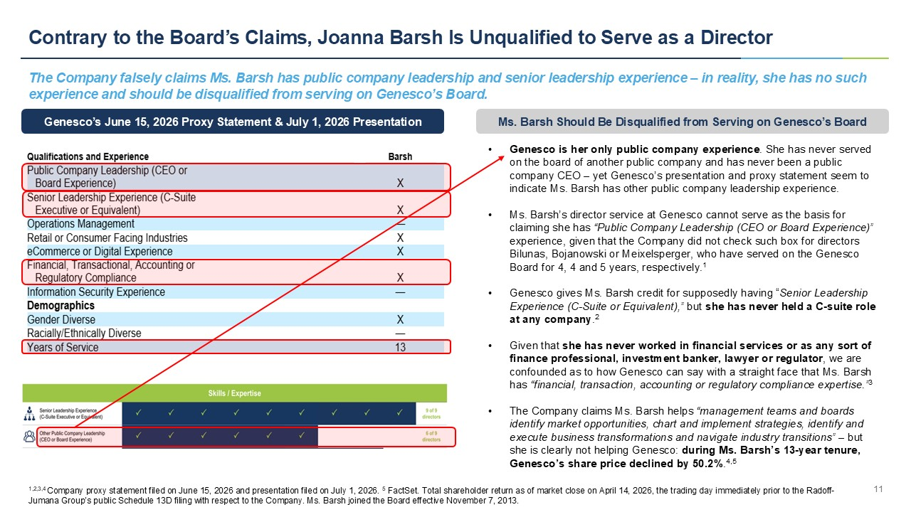
Contrary to the Board’s Claims, Joanna Barsh Is Unqualified to Serve as a Director The Company falsely claims Ms. Barsh has public company leadership and senior leadership experience – in reality, she has no suc h experience and should be disqualified from serving on Genesco’s Board. 11 • Genesco is her only public company experience . She has never served on the board of another public company and has never been a public company CEO – yet Genesco’s presentation and proxy statement seem to indicate Ms. Barsh has other public company leadership experience. • Ms. Barsh’s director service at Genesco cannot serve as the basis for claiming she has “Public Company Leadership (CEO or Board Experience)” experience, given that the Company did not check such box for directors Bilunas , Bojanowski or Meixelsperger, who have served on the Genesco Board for 4, 4 and 5 years, respectively. 1 • Genesco gives Ms. Barsh credit for supposedly having “ Senior Leadership Experience (C - Suite or Equivalent),” but she has never held a C - suite role at any company . 2 • Given that she has never worked in financial services or as any sort of finance professional, investment banker, lawyer or regulator , we are confounded as to how Genesco can say with a straight face that Ms. Barsh has “financial, transaction, accounting or regulatory compliance expertise.” 3 • The Company claims Ms. Barsh helps “management teams and boards identify market opportunities, chart and implement strategies, identify and execute business transformations and navigate industry transitions” – but she is clearly not helping Genesco: during Ms. Barsh’s 13 - year tenure, Genesco’s share price declined by 50.2% . 4,5 Genesco’s June 15, 2026 Proxy Statement & July 1, 2026 Presentation Ms. Barsh Should Be Disqualified from Serving on Genesco’s Board 1,2,3,4 Company proxy statement filed on June 15, 2026 and presentation filed on July 1, 2026. 5 FactSet. Total shareholder return as of market close on April 14, 2026, the trading day immediately prior to the Radoff - Jumana Group’s public Schedule 13D filing with respect to the Company. Ms. Barsh joined the Board effective November 7, 2013.
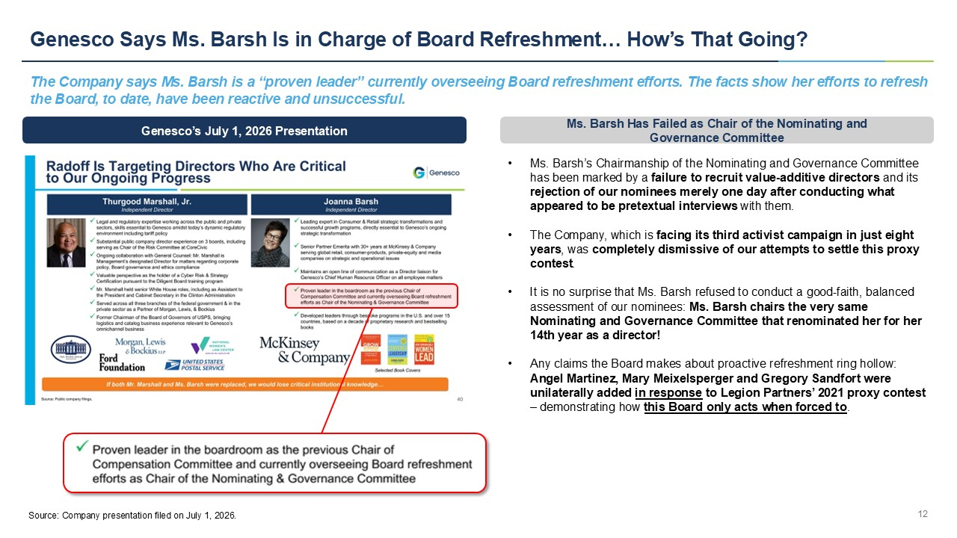
Genesco Says Ms. Barsh Is in Charge of Board Refreshment… How’s That Going? 12 Genesco’s July 1, 2026 Presentation The Company says Ms. Barsh is a “proven leader” currently overseeing Board refreshment efforts. The facts show her efforts to re fresh the Board, to date, have been reactive and unsuccessful. • Ms. Barsh’s Chairmanship of the Nominating and Governance Committee has been marked by a failure to recruit value - additive directors and its rejection of our nominees merely one day after conducting what appeared to be pretextual interviews with them. • The Company, which is facing its third activist campaign in just eight years , was completely dismissive of our attempts to settle this proxy contest . • It is no surprise that Ms. Barsh refused to conduct a good - faith, balanced assessment of our nominees: Ms. Barsh chairs the very same Nominating and Governance Committee that renominated her for her 14th year as a director! • Any claims the Board makes about proactive refreshment ring hollow: Angel Martinez, Mary Meixelsperger and Gregory Sandfort were unilaterally added in response to Legion Partners’ 2021 proxy contest – demonstrating how this Board only acts when forced to . Ms. Barsh Has Failed as Chair of the Nominating and Governance Committee Source: Company presentation filed on July 1, 2026.
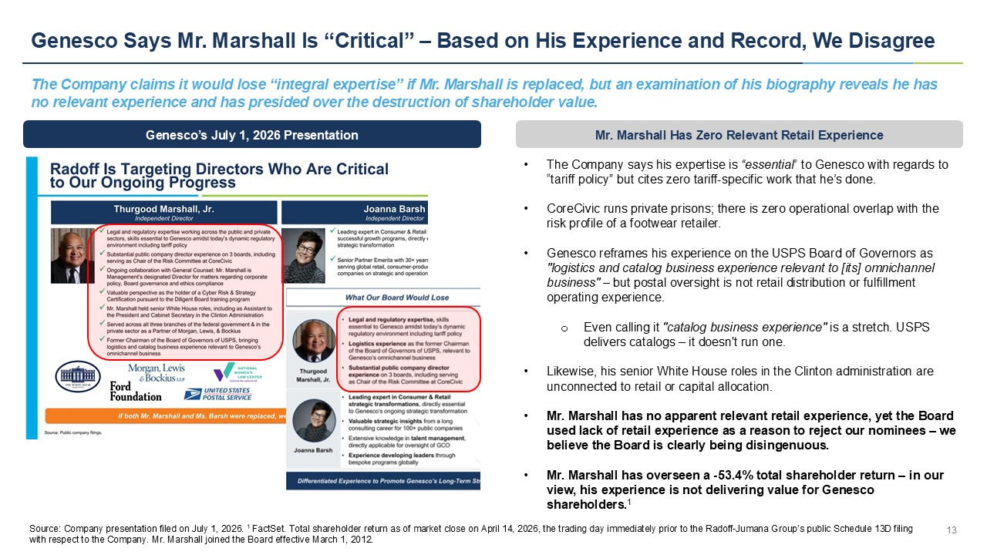
Genesco Says Mr. Marshall Is “Critical” – Based on His Experience and Record, We Disagree 13 Genesco’s July 1, 2026 Presentation The Company claims it would lose “integral expertise” if Mr. Marshall is replaced, but an examination of his biography reveal s h e has no relevant experience and has presided over the destruction of shareholder value. • The Company says his expertise is “essential” to Genesco with regards to “tariff policy” but cites zero tariff - specific work that he’s done. • CoreCivic runs private prisons; there is zero operational overlap with the risk profile of a footwear retailer. • Genesco reframes his experience on the USPS Board of Governors as "logistics and catalog business experience relevant to [its] omnichannel business" – but postal oversight is not retail distribution or fulfillment operating experience. o Even calling it "catalog business experience" is a stretch. USPS delivers catalogs – it doesn't run one. • Likewise, his senior White House roles in the Clinton administration are unconnected to retail or capital allocation. • Mr. Marshall has no apparent relevant retail experience, yet the Board used lack of retail experience as a reason to reject our nominees – we believe the Board is clearly being disingenuous. • Mr. Marshall has overseen a - 53.4% total shareholder return – in our view, his experience is not delivering value for Genesco shareholders. 1 Mr. Marshall Has Zero Relevant Retail Experience Source: Company presentation filed on July 1, 2026. 1 FactSet. Total shareholder return as of market close on April 14, 2026, the trading day immediately prior to the Radoff - Jumana G roup’s public Schedule 13D filing with respect to the Company. Mr. Marshall joined the Board effective March 1, 2012.
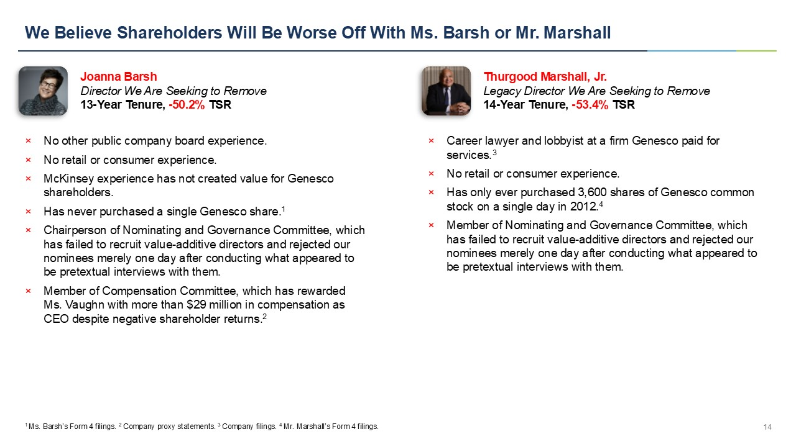
We Believe Shareholders Will Be Worse Off With Ms. Barsh or Mr. Marshall 14 × No other public company board experience. × No retail or consumer experience. × McKinsey experience has not created value for Genesco shareholders. × Has never purchased a single Genesco share. 1 × Chairperson of Nominating and Governance Committee, which has failed to recruit value - additive directors and rejected our nominees merely one day after conducting what appeared to be pretextual interviews with them. × Member of Compensation Committee, which has rewarded Ms. Vaughn with more than $29 million in compensation as CEO despite negative shareholder returns. 2 Joanna Barsh Director We Are Seeking to Remove 13 - Year Tenure, - 50.2% TSR 1 Ms. Barsh’s Form 4 filings. 2 Company proxy statements. 3 Company filings. 4 Mr. Marshall’s Form 4 filings. × Career lawyer and lobbyist at a firm Genesco paid for services. 3 × No retail or consumer experience. × Has only ever purchased 3,600 shares of Genesco common stock on a single day in 2012. 4 × Member of Nominating and Governance Committee, which has failed to recruit value - additive directors and rejected our nominees merely one day after conducting what appeared to be pretextual interviews with them. Thurgood Marshall, Jr. Legacy Director We Are Seeking to Remove 14 - Year Tenure, - 53.4% TSR
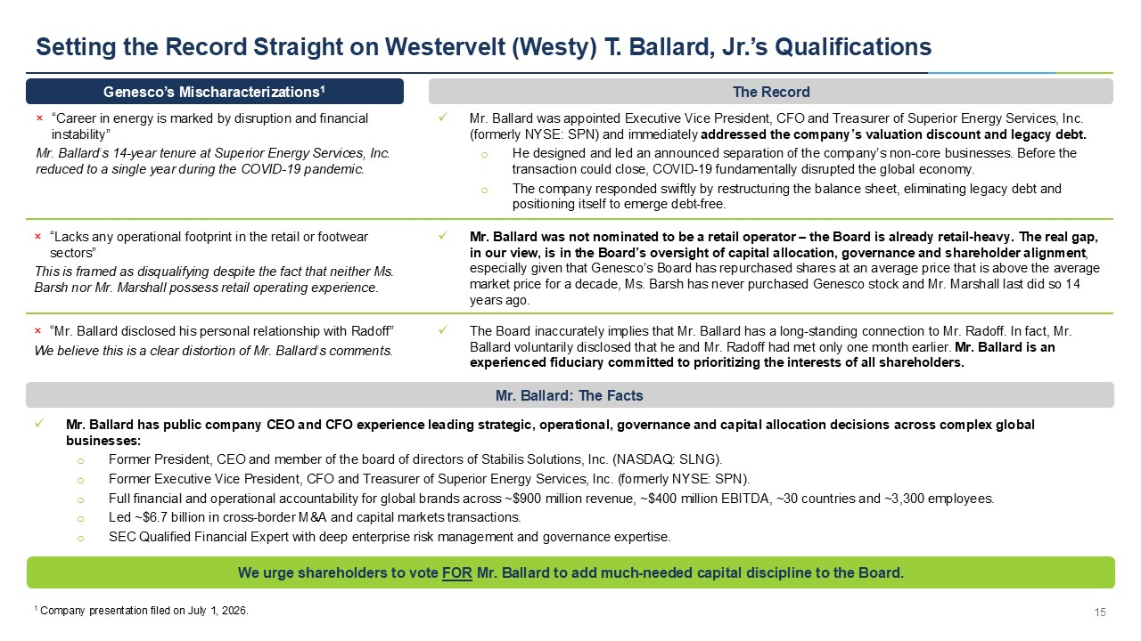
Setting the Record Straight on Westervelt (Westy) T. Ballard, Jr.’s Qualifications 15 x Mr. Ballard was appointed Executive Vice President, CFO and Treasurer of Superior Energy Services, Inc. (formerly NYSE: SPN) and immediately addressed the company’s valuation discount and legacy debt. o He designed and led an announced separation of the company’s non - core businesses. Before the transaction could close, COVID - 19 fundamentally disrupted the global economy. o The company responded swiftly by restructuring the balance sheet, eliminating legacy debt and positioning itself to emerge debt - free. We urge shareholders to vote FOR Mr. Ballard to add much - needed capital discipline to the Board. Genesco’s Mischaracterizations 1 The Record × “Career in energy is marked by disruption and financial instability” Mr. B allard’s 14 - year tenure at Superior Energy Services, Inc. reduced to a single year during the COVID - 19 pandemic. 1 Company presentation filed on July 1, 2026. × “Lacks any operational footprint in the retail or footwear sectors” This is framed as disqualifying despite the fact that neither Ms. Barsh nor Mr. Marshall possess retail operating experience. x Mr. Ballard was not nominated to be a retail operator – the Board is already retail - heavy. The real gap, in our view, is in the Board’s oversight of capital allocation, governance and shareholder alignment , especially given that Genesco’s Board has repurchased shares at an average price that is above the average market price for a decade, Ms. Barsh has never purchased Genesco stock and Mr. Marshall last did so 14 years ago. x The Board inaccurately implies that Mr. Ballard has a long - standing connection to Mr. Radoff. In fact, Mr. Ballard voluntarily disclosed that he and Mr. Radoff had met only one month earlier. Mr. Ballard is an experienced fiduciary committed to prioritizing the interests of all shareholders. × “Mr. Ballard disclosed his personal relationship with Radoff” We believe this is a clear distortion of Mr. Ballard’s comments. x Mr. Ballard has public company CEO and CFO experience leading strategic, operational, governance and capital allocation decisions across complex glo ba l businesses: o Former President, CEO and member of the board of directors of Stabilis Solutions, Inc. (NASDAQ: SLNG). o Former Executive Vice President, CFO and Treasurer of Superior Energy Services, Inc. (formerly NYSE: SPN). o Full financial and operational accountability for global brands across ~$900 million revenue, ~$400 million EBITDA, ~30 count rie s and ~3,300 employees. o L ed ~$6.7 billion in cross - border M&A and capital markets transactions. o SEC Qualified Financial Expert with deep enterprise risk management and governance expertise. Mr. Ballard: The Facts


